# **Omnipod Downloading at Home**

# **How do I install the Glooko Uploader?**

The Glooko Uploader is an easy-to-use software tool that allows you to sync diabetes device data to the Glooko web app. In order to use the Glooko Uploader, you will need to complete a quick installation process.

**To get started, select your user type:**

* [Patient](https://support.glooko.com/hc/en-us/articles/115003858029#patient)
* [Healthcare Provider](https://support.glooko.com/hc/en-us/articles/115003858029#hcp)

**Install the Glooko Uploader (Patient)**

In order to access the Glooko web app and download the Glooko Uploader software, you will need a Glooko account.

#### ****Step 1: Sign into the Glooko web app****

1. Go to [my.glooko.com](https://my.glooko.com/) in your web browser.
2. Enter your **Email** **Address** and **Password**.
3. Click **Sign In**. You will be routed to your Glooko account.

#### ****Step 2: Download the Glooko Uploader installation file****

After logging into your Glooko account on the web, you will need to download the installation file.

To download the installation file:

1. Click **Settings** at the top-right of the screen.
2. Scroll to the Apps & Devices section at the bottom of the page and click **Get Glooko Uploader**.
3. You will be routed to a screen with options to install the Glooko Uploader on a Mac or PC. Select your operating system to download the installation file.
4. After the installation file is downloaded, you will need to locate and run that file.
   * If you are using a **PC**: Look in your Recent Downloads folder.
   * If you are using a **Mac**: Look in your Downloads folder in the Finder app.
5. Once you’ve located the file, double-click on it and follow the on-screen instructions to install the application.

You will be required to restart your computer at the end of the installation process.

# **How do I upload diabetes data on the web using the Glooko® Uploader?**

With the Glooko Uploader, you can easily upload data from a compatible diabetes device using your PC or Mac computer.

To get started, you will need:

1. A compatible diabetes device
2. The Glooko Uploader software installed on a PC or Mac
3. A Glooko account
4. The syncing or device download cable that came with the diabetes device

Ready to start uploading? Just follow the three simple steps outlined below.

#### ****Step 1: Connect the cable for the diabetes device to your computer.****

* Connect the appropriate USB cable or infrared (IR) cable for the diabetes device to your computer.
* Once the cable is recognized, wait a few seconds for the cable drivers to be recognized before connecting the device.

#### ****Step 2: Connect the diabetes device to the cable.****

* After connecting the cable to your computer, connect the diabetes device to the other end of the cable.

#### ****Step 3: Upload the diabetes device data.****

* After connecting the cable to your computer and diabetes device, the device will begin uploading data using the Glooko Uploader.
* Once the data has been successfully uploaded, you will have the option to upload another device or view the data.

**NOTE:** The first time you upload data from a device, you may be asked to validate your user account. If prompted, enter your Glooko username and password to complete the upload and assign the device to the account. 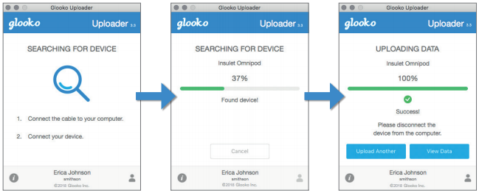

**To upload your Omnipod DASH™**

**Part 1: Update the data file on your DASH PDM**

1. Turn your DASH PDM off, then turn it back on.
2. Enter your PIN Code to unlock your DASH.
3. Plug one end of your USB-A to Micro cable into your computer and the other end of your cable into your DASH PDM.
4. Tap **Export** on the DASH PDM to export your data.
5. Tap **Done/OK.**
   * The new data file should now be created and updated on your DASH PDM.

**Part 2: Upload the data to Glooko Uploader**

1. Unplug your DASH PDM from the cable.
   * Ensure that it is *on* and *unlocked*.
2. Plug the cable back into your DASH PDM.
3. Tap the **Export** option on your DASH PDM.
4. Open the Glooko Uploader software on your computer and ensure you are logged into your Glooko account. The data upload will begin automatically.
5. Once the upload has completed, click **Done**.